I2C Communication requires Total Phase Aardvark I2C/SPI host adapter. J7 Pin 14 must be pulled low.

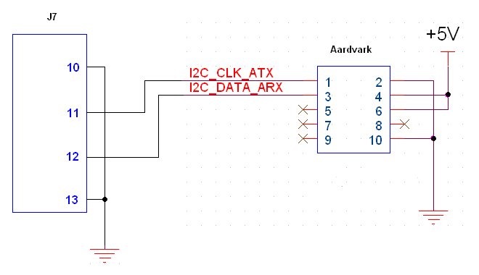

Asynchronous Serial communication requires an FTDI P/N TTL-232R-5V USB converter cable. J7 Pin 14 must be left high (open).

J7-10 to Pin 1 GND

J7-11 to Pin 5 RXD

J7-12 to Pin 4 TXD